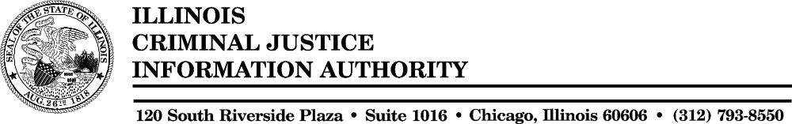

MINUTES

JUVENILE CRIME ENFORCEMENT COALITION

March 14, 2006

120 South Riverside Plaza
Chicago, Illinois

Call to Order and Roll Call

Chairman Sorosky called the Juvenile Crime Enforcement Coalition (JCEC) meeting to order. Associate Director Chojnacki called Roll. JCEC members participating via teleconference were:

Rodney Ahitow
Pat Connell
Bridget Healy Ryan
Gary Leofanti
Mike Mahoney
Sheldon Sorosky
Wayne Straza

Authority staff present included: Ronnie Reichgelt, Amy Kelly, Sherry Barnett, Lajuana Murphy, Jude Lemrow, Jennifer Vesely and Sylvia Szubielski.

FFY03 NATIONAL JUVENILE SERVICES TRAINING INSTITUTE CONFERENCE

Staff recommended that $100,000 of the FFY03 State/Discretionary funds be designated for scholarships to the National Juvenile Services Training Institute conference in Indianapolis, Indiana this coming June. Staff requested permission, as given in the past, to make awards of these funds and report back to the Budget Committee at a future meeting as to which agencies received funding. Mr. Mahoney made a motion to approve this request, seconded by Ms. Healy Ryan and approved by unanimous voice vote (7-0-0-1) as follows:

Aye-7 Nay-0 Present-0 Absent-
Mr. Ahitow Mr. Friedeneur
Ms. Connell Mr. Lonbom
Ms. Healy Ryan
Mr. Leofanti
Mr. Mahoney
Mr. Sorosky
Mr. Straza

Mr. Reichgelt explained that the Chicago Police Department would be attending next weeks meeting, as well as representatives from Chicago Youth Services. He inquired regarding what materials staff should prepare for that meeting. Members felt it would be appropriate to compile a revised proposal, budget and budget narrative for the mailing.

ADJOURN

With no futher issues to discuss, Mr. Mahoney made a motion to adjourn.

